***CC in the Cloud* - ISO15408 Roadmap Contribution**

**4.x Change A**

*Shorthand scheme for identifying changes is to be discussed later. It could be a letter (A-Z then AA-ZZ…​) or a keyword, or both. This shorthand scheme****should not****require heavy maintenance.*

CC in the Cloud

**4.x.1 Description**

*This subclause is description text that is ideally ready to be reused in the Description field of a New Work Item proposal.*

There is not yet a defined and accepted method within the Common Criteria that addresses IT product evaluations in the cloud environment.

Today, CC reflects a static point in time for security evaluation methodology. Over the past several years, members of this TWG have witnessed customer migrations from an on-premise model where products are licensed and maintained via a services model where assurance benefits accrued from CC are not available in the cloud.

Customers are buying services, not products. “Gartner foresees double-digit growth in government use of public cloud services, with spending forecast to grow on average 17.1% per year through 2021.” --Understanding cloud Adoption in Government

“In fiscal 2019, the White House-issued cloud Smart strategy gave agencies a mandate to expedite their journeys to the cloud. Federal agencies spent a combined $5.9 billion in contract obligations on cloud infrastructure as a service (IaaS), platform as a service (PaaS), software as a service (SaaS), and other cloud support and migration services. They’re on track to spend $7.1 billion in fiscal 2020.”--The State of Federal cloud: Market Briefing

**4.x.2 Justification**

*This subclause is description text that is ideally ready to be reused in the Justification field of a New Work Item proposal.*

Customers are going to recognize that a CC evaluation of an Information Communication Technologies (ICT) product provides little assurance in a cloud environment. Without a plan for CC addressing this factor, CC will become irrelevant in many real-world scenarios and customers will require additional country specific testing instead.

As the market moves to such cloud-based solutions, ISO/IEC15408 should be adapted in order to provide security assurance for cloud scenarios. In addition, vendors of products to be evaluated along with authors of s Profiles(PPs) aimed at cloud use case evaluations, may need to add or alter specific code or PP content carefully to ensure evaluate-able products and PPs.

Products utilizing cloud platforms are expected to be evaluated within one of the following use cases:

The following examples are provided for additional context. They are not fully representative of all possible cloud evaluation scenarios and are not intended to be an exclusive set.

**Use Case 1**: Software as a Service (SaaS). The capability provided to the consumer is to use the provider’s applications running on a cloud infrastructure. The applications are accessible from various client devices through either a thin client interface, such as a web browser (e.g., web-based email), or a program interface. The consumer does not manage or control the underlying cloud infrastructure including network, servers, operating systems, storage, or even individual application capabilities, with the possible exception of limited user specific application configuration settings.

The following PPs are examples which might be extended with CC in the Cloud methodology to cover the above use case: cPP_App_SW, cPP_DBMS, PP_MDM.

For example, if the cPP for Application Software were to be used as a baseline the cloud extensions may be applied to the existing TOE Boundary and TOE Platform given in the following diagram:

[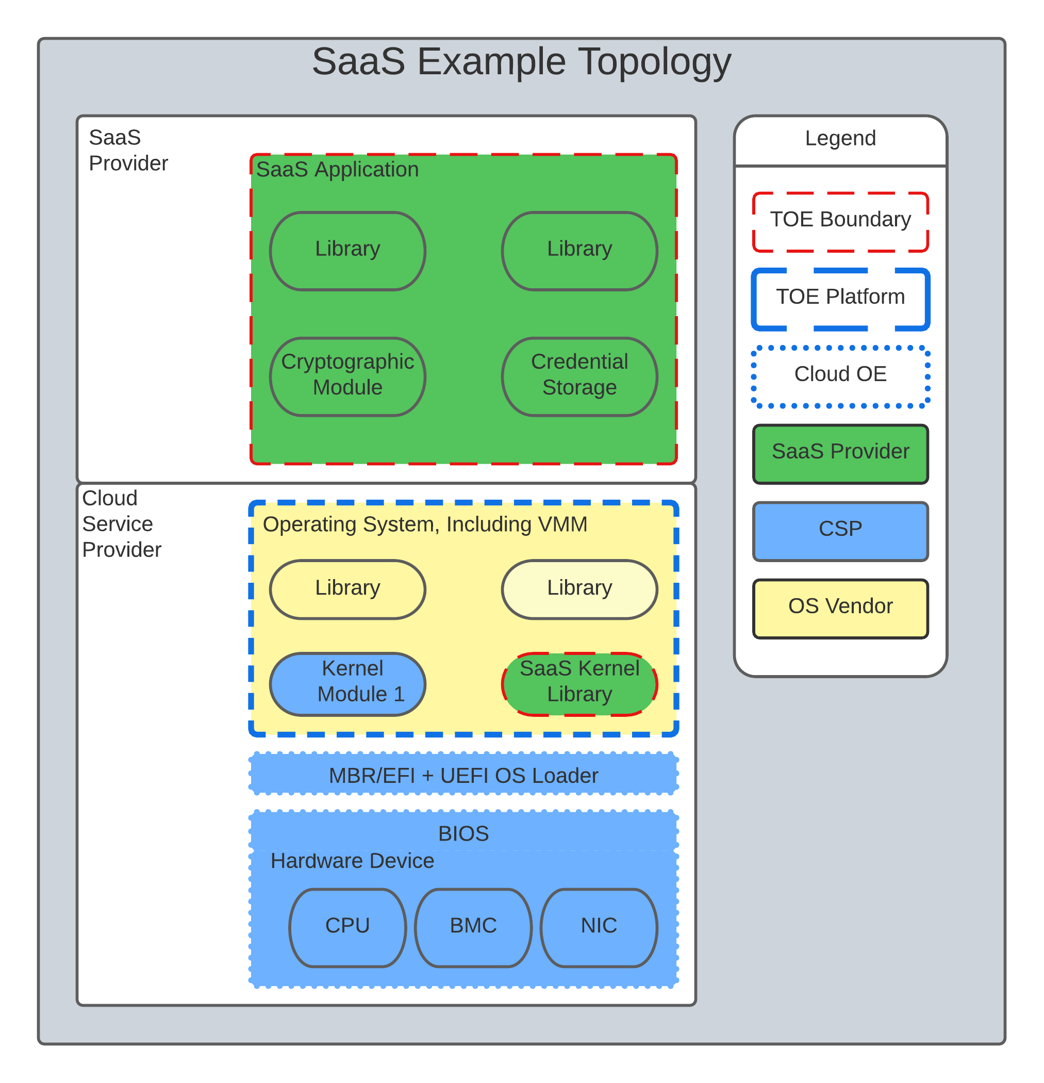](https://github.com/CC-in-the-Cloud/Admin/blob/Working/ISO/images/saas.png)

Figure 1. SaaS Example

In this example, the SaaS Application provided by the SaaS provider relies on a TOE platform from an OS Vendor, which is hosted by the Cloud Service Provider on the CSPs hardware. In this Cloud evaluation scenario, additional TSS and Assurance Activities could be prescribed to expand the evaluated configuration in a Cloud Operating Environment.

**Use Case 2**: Platform as a Service (SaaS). The capability provided to the consumer is to deploy onto the cloud infrastructure consumer-created or acquired applications created using programming languages, libraries, services, and tools supported by the provider. The consumer does not manage or control the underlying cloud infrastructure including network, servers, operating systems, or storage, but has control over the deployed applications and possibly configuration settings for the application-hosting environment.

The following PPs are examples which might be extended with CC in the Cloud methodology to cover the above use case: GP_OS_PP, cPP_ND.

For example, if the Protection Profile for General Purpose Operating System were to be used as a baseline, the cloud extensions may be applied to the existing TOE Boundary and Cloud Operating Environment given in the following diagram:

[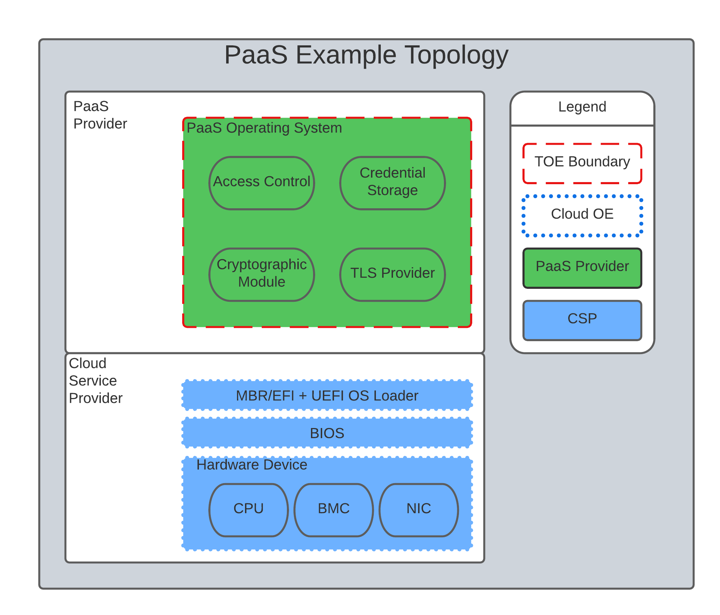](https://github.com/CC-in-the-Cloud/Admin/blob/Working/ISO/images/paas.png)

Figure 2. Paas Example

In this example, the PaaS OS provided by the PaaS provider relies on a Cloud Operating Environment, which is hosted by the Cloud Service Provider on the CSPs hardware. In this Cloud evaluation scenario, additional TSS and Assurance Activities could be prescribed to expand the evaluated configuration in a Cloud Operating Environment.

**Use Case 3**: Infrastructure as a Service (SaaS). The capability provided to the consumer is to provision processing, storage, networks, and other fundamental computing resources where the consumer is able to deploy and run arbitrary software, which can include operating systems and applications. The consumer does not manage or control the underlying cloud infrastructure but has control over operating systems, storage, and deployed applications; and possibly limited control of select networking components (e.g., host firewalls)

The following PPs are examples which might be extended with CC in the Cloud methodology to cover the above use case: PP_BASE_VIRTUALIZATION

For example, if the Protection Profile for Virtualization were to be used as a baseline the cloud extensions may be applied to the existing TOE Boundary and Cloud Operating Environment given in the following diagram:

[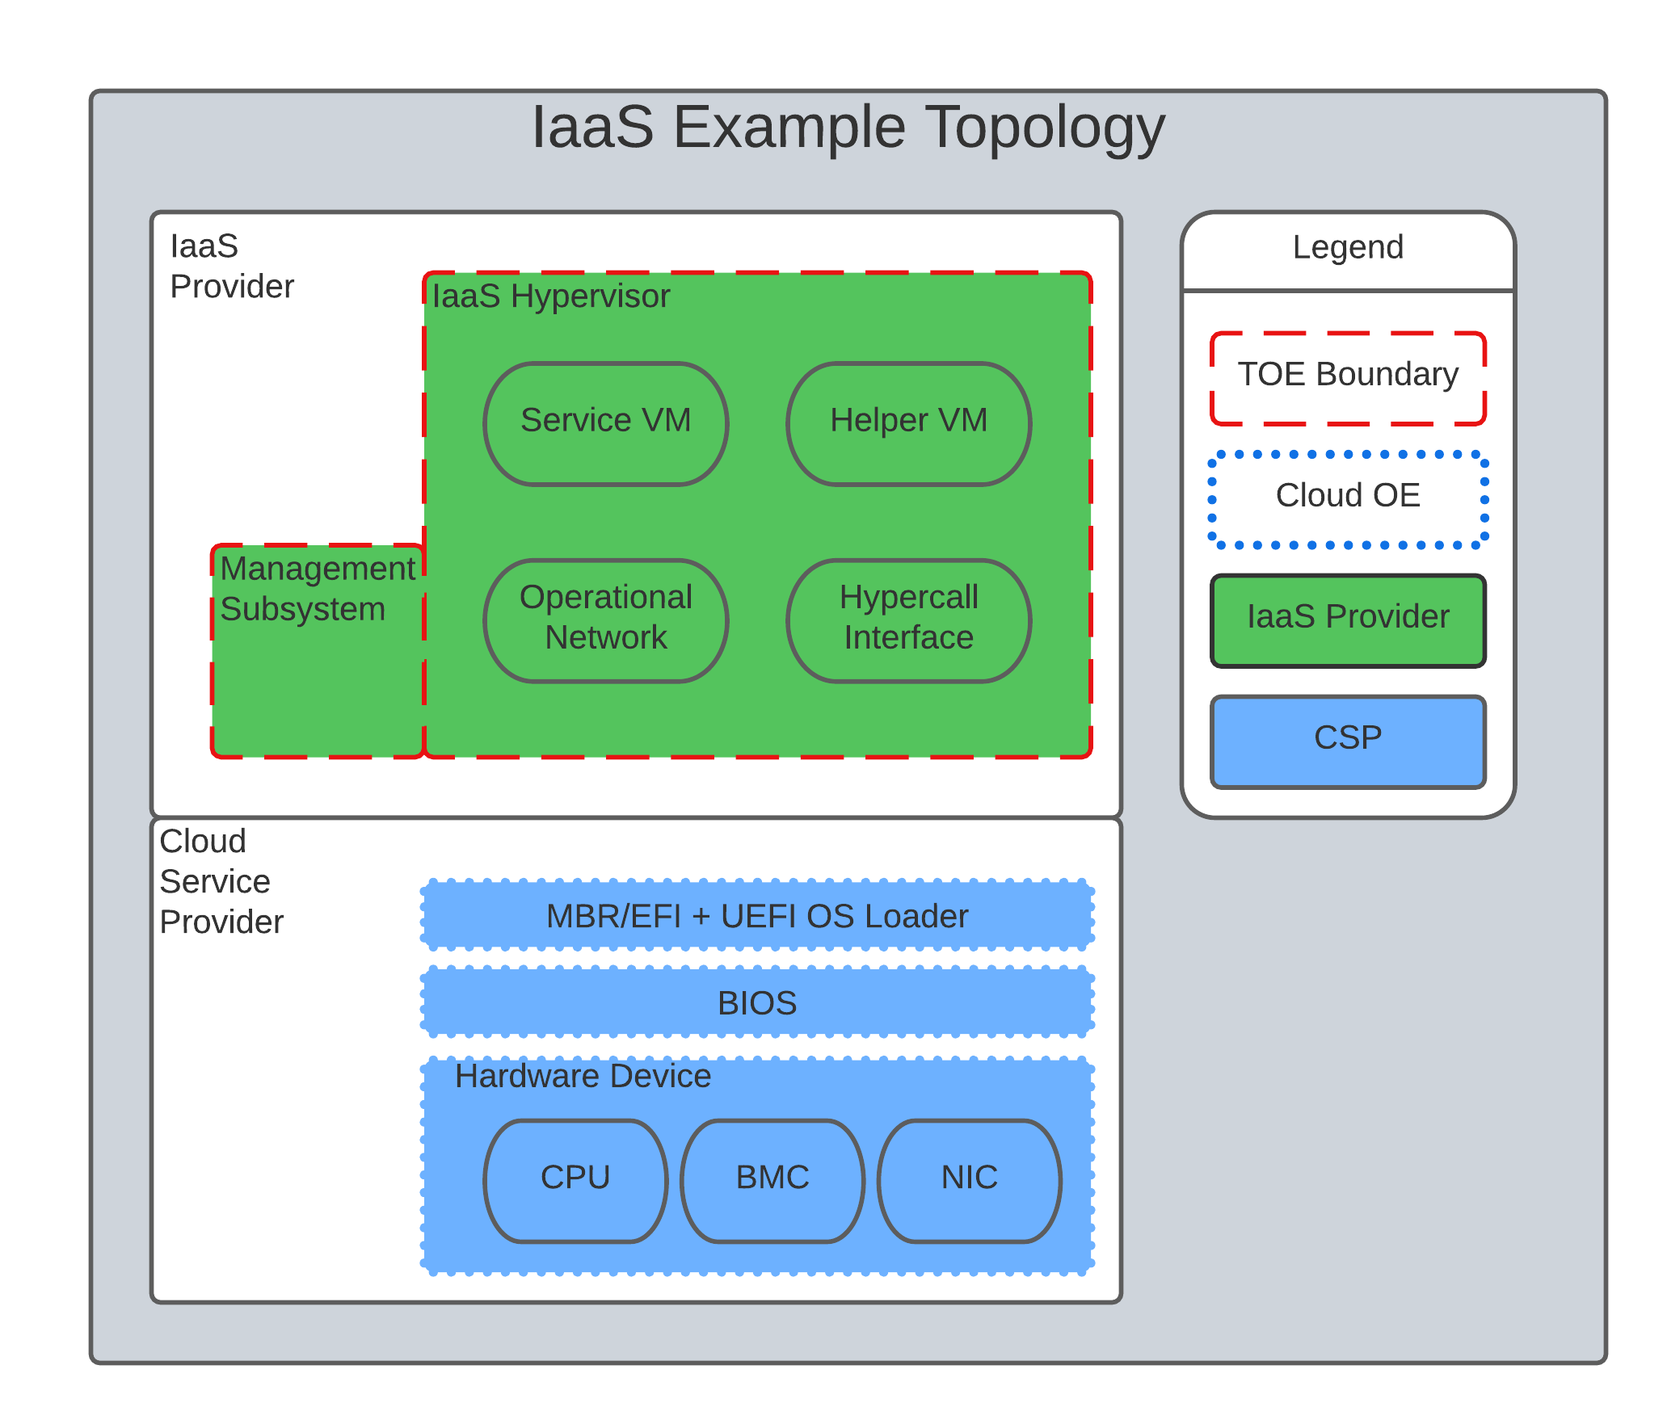](https://github.com/CC-in-the-Cloud/Admin/blob/Working/ISO/images/iaas.png)

Figure 3. IaaS Example

In this example, the IaaS hypervisor provided by the IaaS provider relies on a Cloud Operating Environment, which is hosted by the Cloud Service Provider on the CSPs hardware. In this Cloud evaluation scenario, additional TSS and Assurance Activities could be prescribed to expand the evaluated configuration in a Cloud Operating Environment.

**4.x.3 Input from previous work (optional)**

*This subclause provides pointers to previous standardisation work (beyond ISO/IEC 15408 and 18045 themselves) to be taken as input. If the previous work being referred to has been published (as a standard or other document), it should also be listed in the Bibliography section.*

For initial consideration, the following assumption is being developed that may reference existing standards beyond ISO/IEC15408.

**Trusted Platform**

Cloud based service models inherently incur a trust relationship to certain components of the Information Technology solution.

End users of Common Criteria in the Cloud certificates will require that changes to the underlying infrastructure do not degrade the security functionality of the TOE. This work will propose an approach that will allow for composable construction of a trusted platform concept by leveraging existing collateral.

Areas for consideration may include:

* Any existing Common Criteria Certificates valid for the TOE Environment.
* Any existing cryptographic collateral information (e.g. ISO/IEC 19790 or equivalent ) for the TOE Environment.

**Trusted Provider/Admin**

Similarly to the Trusted Platform concept from above, additional collateral is appropriate with regards to the Cloud Service Provider and their role as a Trusted Administrator.

Areas for consideration may include:

* Specify any existing ISO/IEC 27001/2 certificate information.
* Specify any existing ISO/IEC 20243 (e.g. Open Group Trusted Technology Provider Standard) certificate information for the TOE Environment.

**4.x.4 Related work (optional)**

*This subclause provides information on to parallel standardisation work within JTC 1, ISO or IEC and work of interest in liaisons organisations, and may qualify how these relate to the considered change (potential input, necessary adjustments, possible inconsistencies…​)*

CCUF has a Technical Community working on this topic. In February 2022, an 'Essential Security Requirement' document was produced as required for this group to become an official International Technical Community(iTC) under the CCMC (Common Criteria Management Committee). Consequently, the group expect to develop a guidance document that can be an input for this topic for ISO/IEC15408.

In addition, developments in patch management/maintenance will be important to support this topic.

**4.x.5 Impacted documents and clauses**

*Lists impacted parts of 15408 or 18045, possibly at clause or subclause level.*

Investigations have generated the following Known Evaluation Methodology Gaps

**Analysis is Static**

Traditional product evaluations, most equivalent to SaaS use cases, must adopt rigid and static boundaries with regards to product version, platform components, and product scope. These considerations are problematic when adopted to a dynamic operating environment like the cloud.

Explicit detail of all TOE and Platform configurations and interactions between layers is required to ensure validation. Cloud certifications would likely require the concept of a Trusted Platform in which this detail often unknown and ephemeral, but the security posture is not diminished.

**Use of Cryptography**

Current cryptography certification frameworks rely on extremely detailed algorithm, implementation, and entropy details that are not always available or predictable to end users or product vendors on various cloud platforms or environments.

**Platform Abstraction**

Existing TOE composition requires stability in both the TOE and TOE Platform. The TOE operating environment in a cloud use case may or may not change dramatically due to a variety of factors such as hardware deprecation, underlying firmware updates, OS changes, etc. These changes may or may not be detected by the TOE and may or may not affect the TOE security posture.

New methodology to address minimum satisfactory capabilities in this regard will be required to bridge this gap, such as a Trusted Platform scheme.

**Environmental Evolution**

Cloud environments are evolving as routine in order to provide new services and greater efficiencies to customers. Traditional certifications can not match pace. Furthermore, as cloud Hosting agreements are negotiated independently, access to the same platform or platforms used to evaluate a product cannot be guaranteed to the Common Criteria end user.

**Additional threat model concerns for CC in the Cloud**

Review and monitoring of relevant Cloud Security Frameworks will be considered to capture additional threat considerations or assurance requirements. The following items were identified as particularly relevant for CC in the Cloud efforts.

**Configuration**

As cloud environments offer tremendous benefits of scale to IT Solutions, it is beneficial for product vendors to leverage autonomous deployment and delivery of TOE components. Traditional CC evidence such as Guidance Supplements or access to physical hardware may be difficult for cloud evaluations.

For example, container repositories and/or container orchestration configurations represent an area of interest for products and services using a cloud model that would require attention from PP or ST Authors and Evaluators targeting CC in the Cloud evaluations.

**Credentials**

Traditional CC evaluations typically rely on trusted network or administrator assumptions with regards to credentials and credential management. As cloud environments inherently challenge these assumptions, it is critical to extended SFRs and SARs to meet additional TOE security objectives.

It is not sufficient to solely rely on data-at-rest protections for credentials or key material. CC in the Cloud evaluations must consider the entire lifecycle of secrets, (to include generation, destruction, revocation, etc.) as well as any escrow needed to maintain product operations.

For example, a SaaS application that connects to a datastore may or may not be provisioned manually or programmatically. PP or ST Authors that wish to evaluate applications in a cloud deployment must ensure that credentials used to connect and encrypt/decrypt data within the cloud platform are not vulnerable to compromise.

**Data Sovereignty**

As cloud services often span various geographic and political jurisdictions it is critical to understand these aspects when a product is deployed in a Cloud Environment.

For example, CC in the Cloud evaluations with configuration settings pertinent to data center location may be needed to describe these elements in the appropriate design or lifecycle documentation.

**Key Management**

Cloud service models inherently require compute, network, and storage resources to be dynamically provisioned and de-provisioned programmatically. This presents unique challenges with providing encryption capabilities due to the need to orchestrate key management and delivery. CC in the Cloud considerations must extend assurance such that these capabilities are clearly defined and understood within the scope of evaluation.

For example, virtual machines or containers that leverage encrypted storage volumes often require additional operational components to provide pre-boot authentication and/or HSM services for decryption operations. The key hierarchy and lifecycle within the CC in the Cloud use case are of additional concern in this threat model.

**Insider Threat**

Products and services provided through the cloud require trust on behalf of the vendors and user that extends to operational personnel far above non-cloud deployments.

This work will consider requirements or expansion of scope that includes ALC deliverables to satisfy these additional threat concerns.

**Multi-tenant**

Conventional CC evaluations typically assume that the TOE platform or underlying infrastructure is controlled at the enterprise level by a singular entity within the enterprise. In cloud environments, this assumption cannot be included as the nature of cloud services inherently introduces an aspect of multiple enterprises (multi-tenant) sharing resources both physical and logical.

For example, cloud customers of ICT products understand that moving to the cloud means sharing infrastructure with other customers. While Cloud Providers offering IaaS capabilities may offer dedicated hardware or instances to one cloud customer, this is the minority of cloud use cases.

This work will consider products deployed in a multi-tenant environment with respect to any optional or objective SFRs involving cloud use cases that mitigate Guest Escape, Data Leakage, Privilege Escalation, etc.